**Create two VPC's in different regions and connect the two vpc's.**

BY

Cheerlaswapna

1. **Create VPCs:**

* Go to the AWS Management Console.
* Navigate to the VPC dashboard.
* Click on "Create VPC".
* Specify the details such as VPC name, IPv4 CIDR block, and the region where you want to create the VPC.
* Repeat the above steps to create another VPC in a different region.

**2. Create Subnets:**

* Within each VPC, create subnets in different Availability Zones (AZs) to ensure high availability.
* Associate each subnet with the respective VPC.

**3. Internet Gateway (IGW):**

* Attach an Internet Gateway to each VPC to enable internet access.
* Update the route tables of the subnets to route traffic to the Internet Gateway.

**4. Create VPC Peering Connection:**

* Navigate to the VPC dashboard.
* Click on "Peering Connections" and then "Create Peering Connection".
* Select the first VPC as the requester and the second VPC as the accepter.
* Update the route tables of both VPCs to allow traffic to flow through the peering connection.

**5. Update Security Groups and Network Access Control Lists (NACLs):**

* Update security groups and NACLs to allow traffic between the peered VPCs as per your requirements.

**6. Testing:**

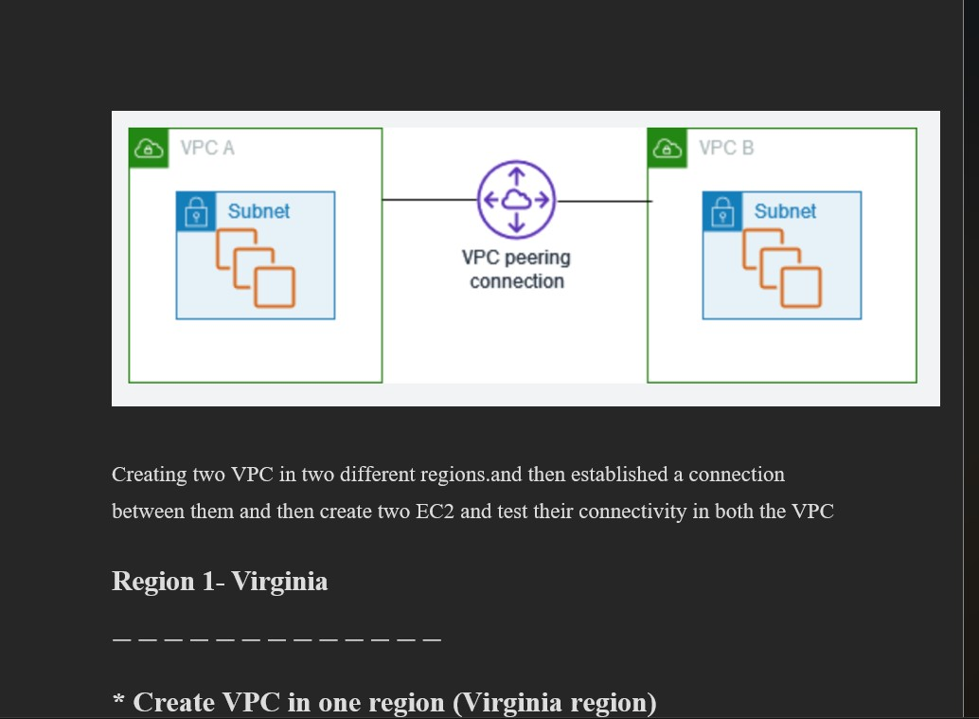

*To creat vpc1 in virginia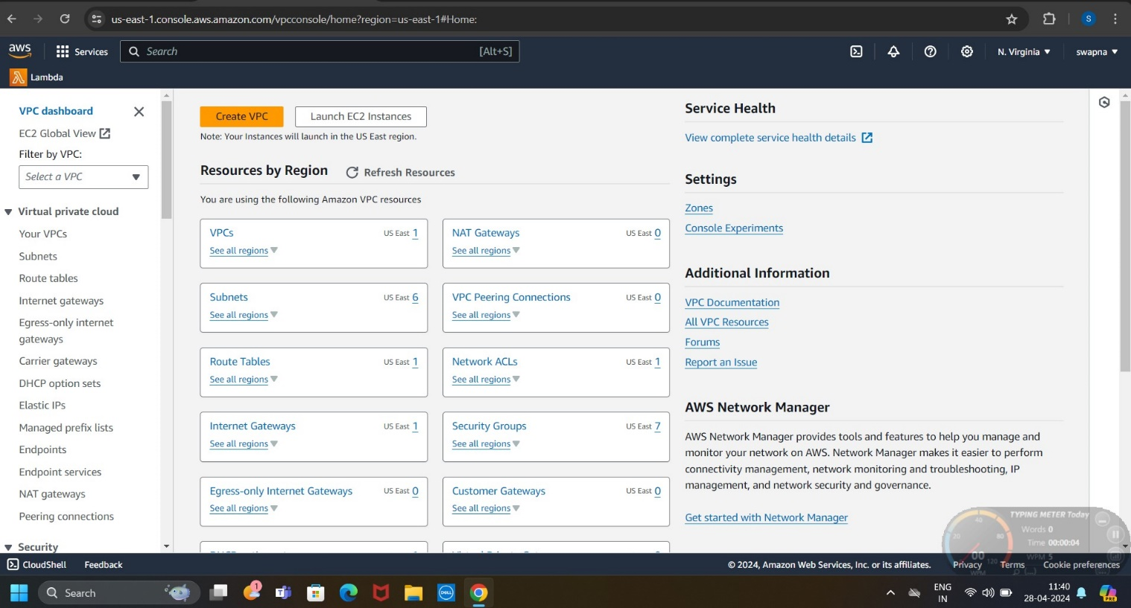

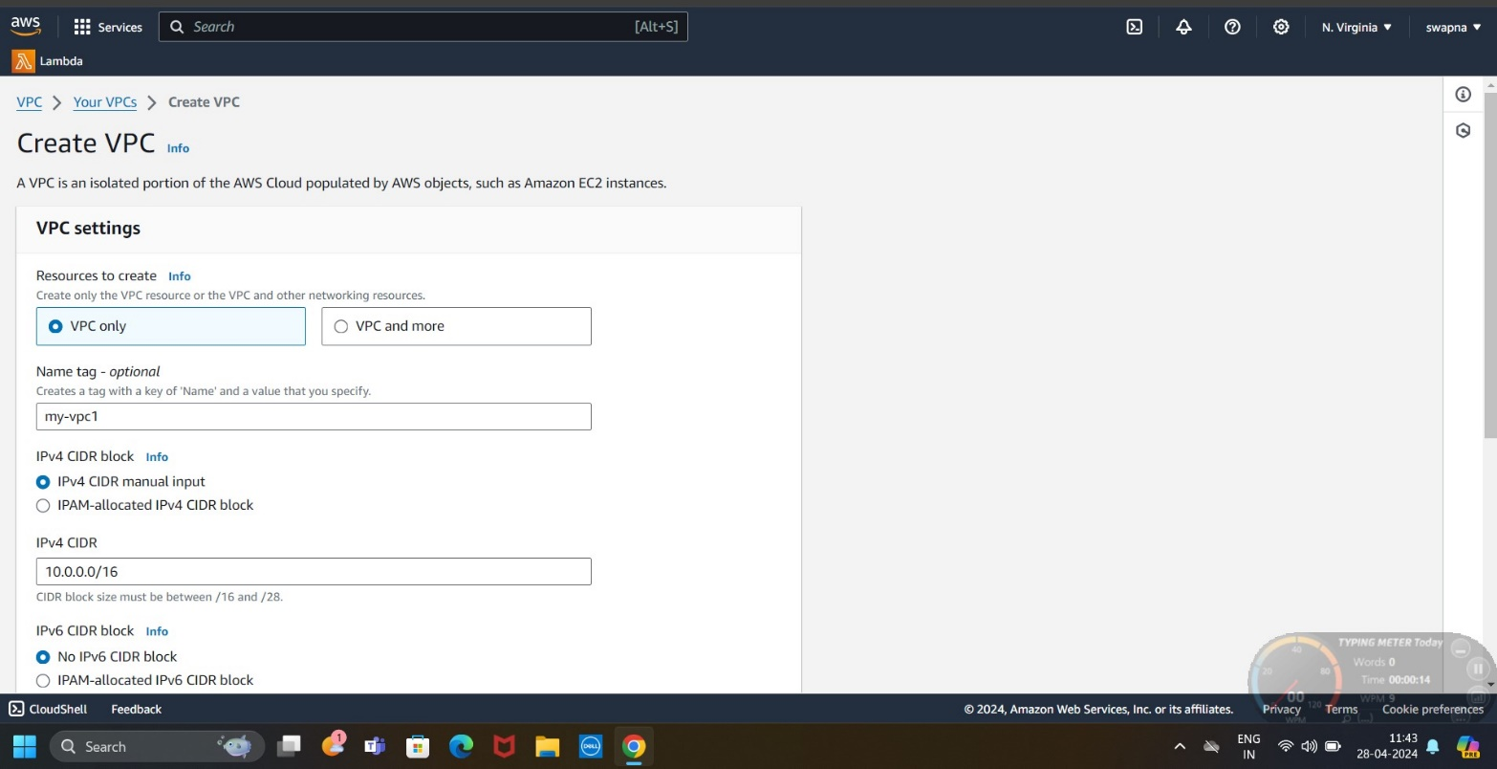

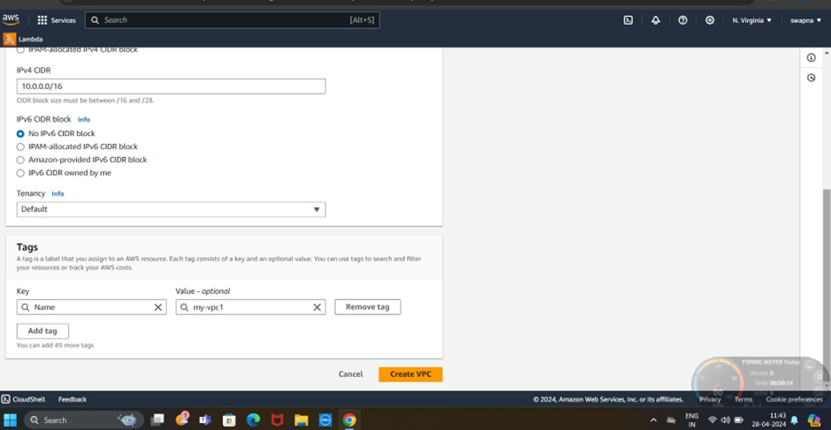

*To create asubnet1

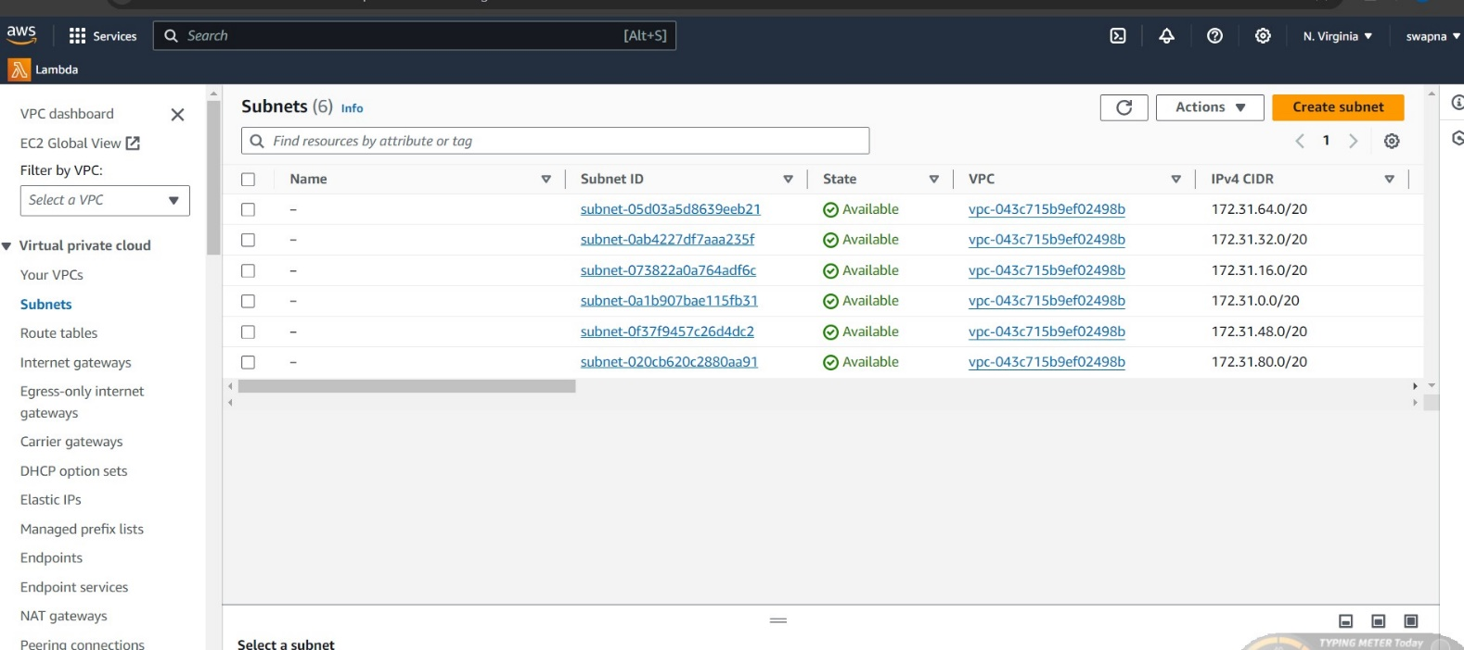

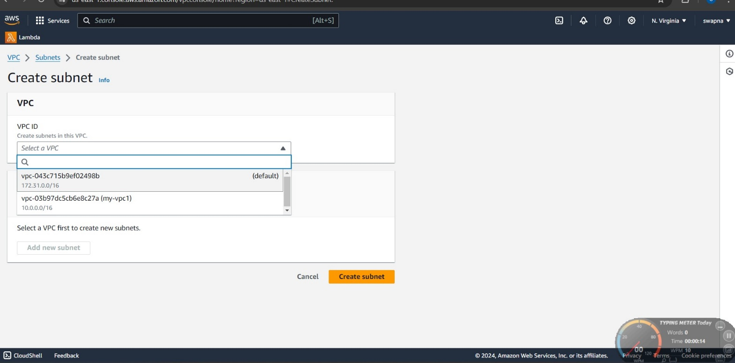

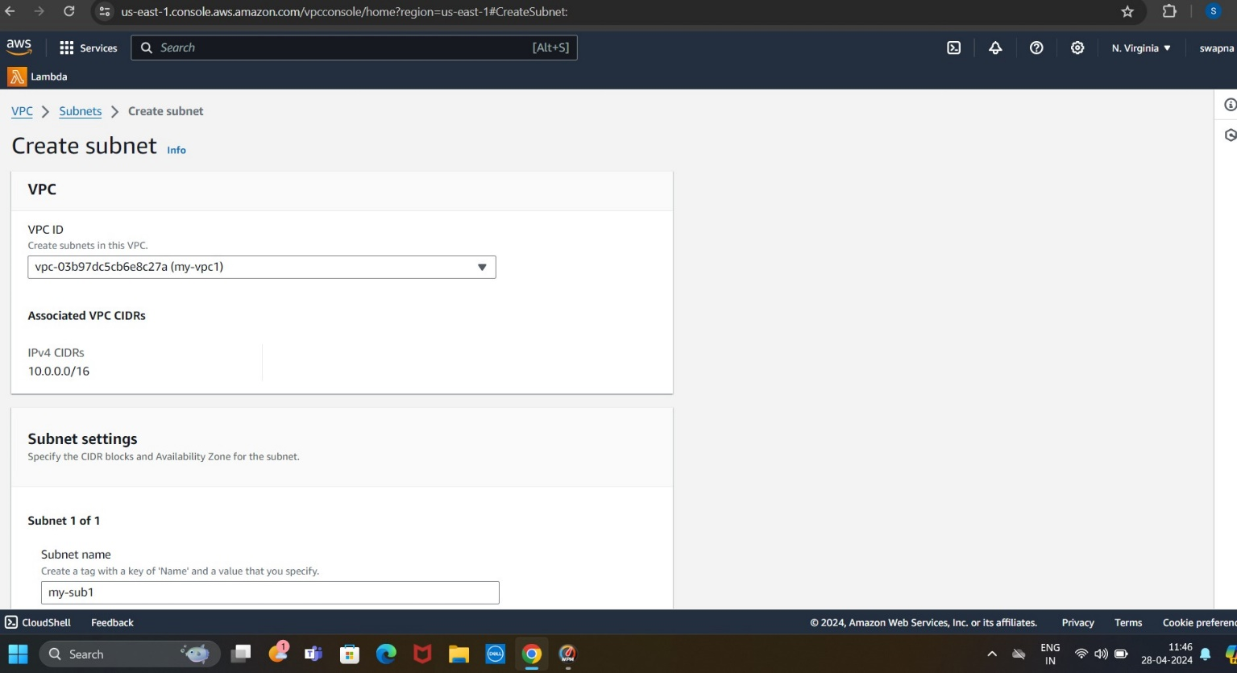

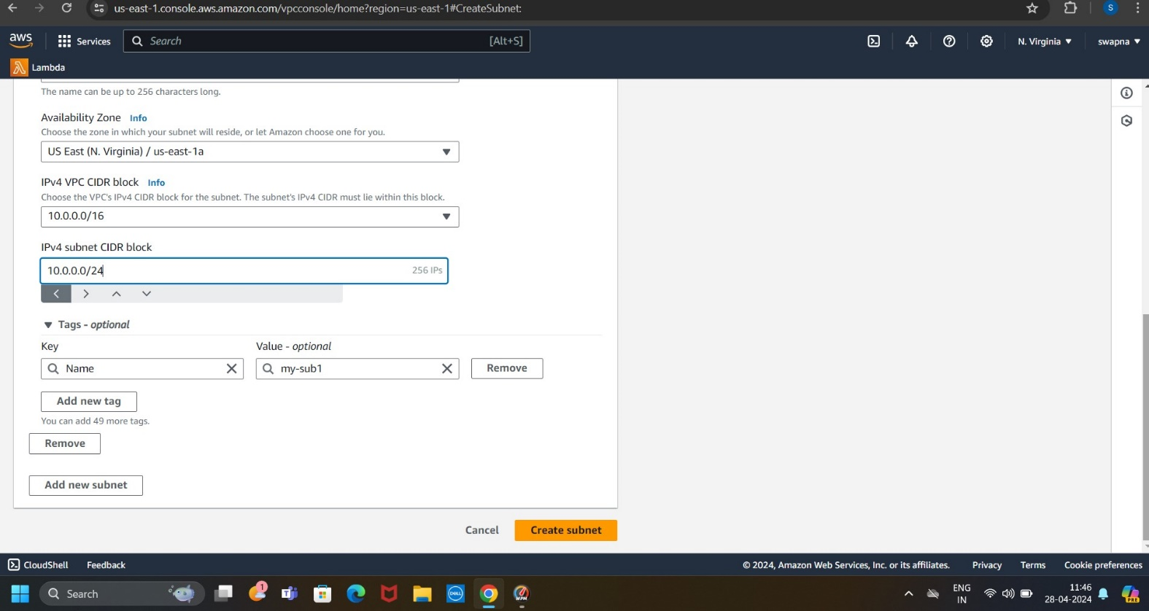

*To create a internet getway

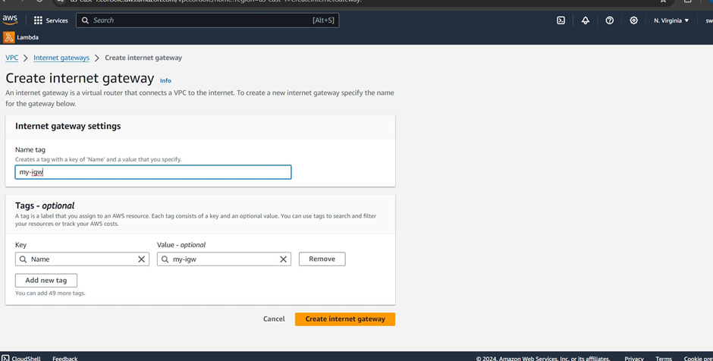

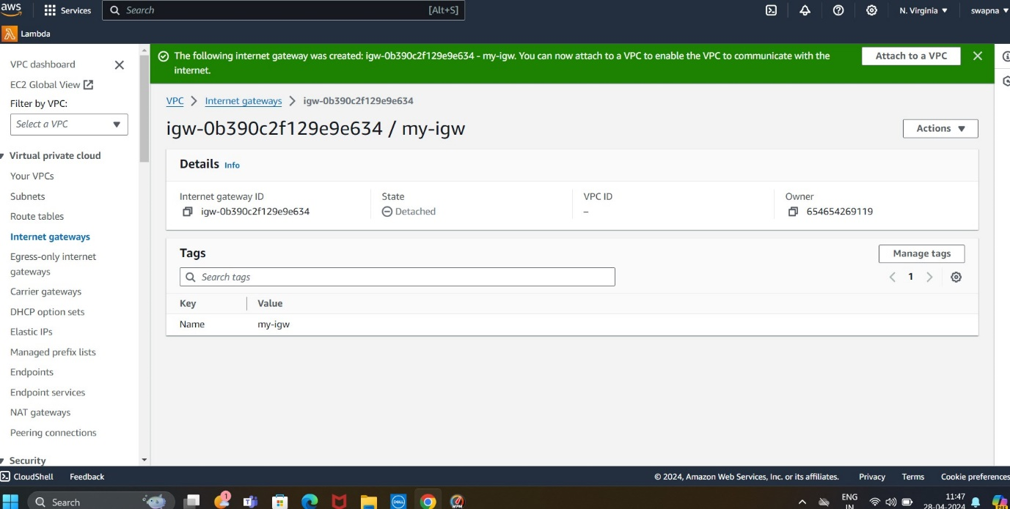

*To create a route table 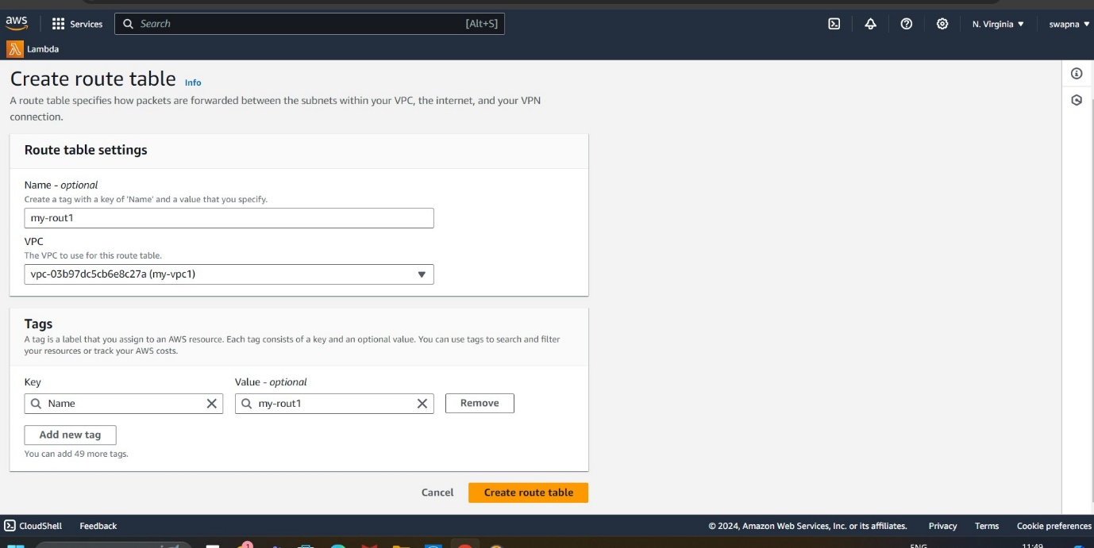

*To edite route table

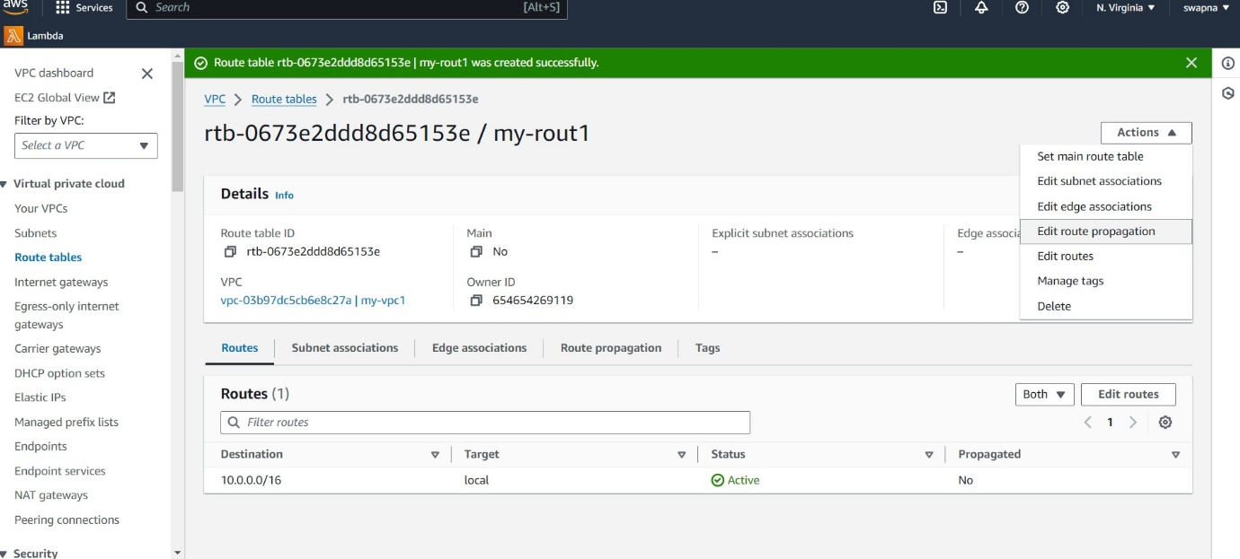

* Adda to internet gatway

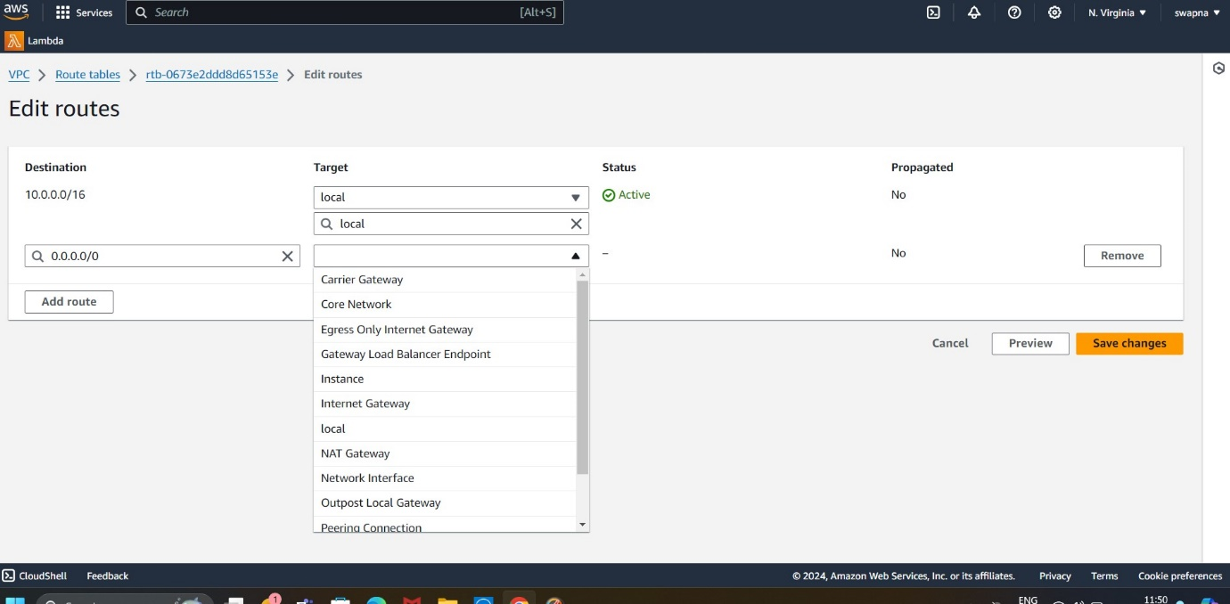

*To edite subnet associations

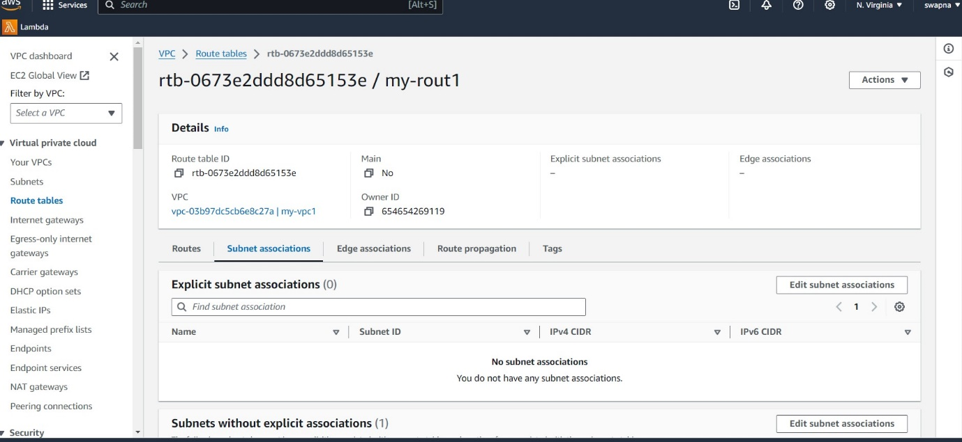

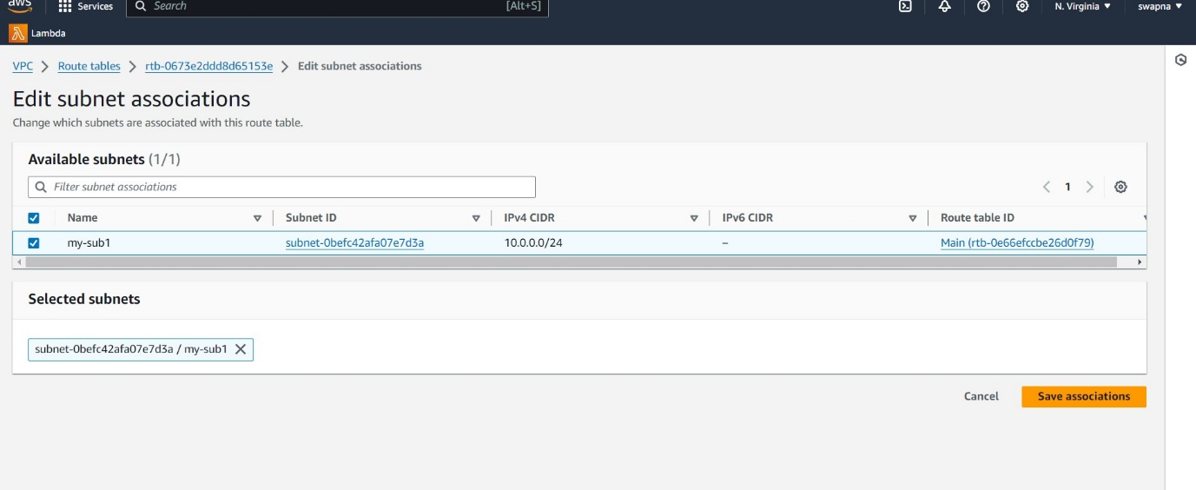

*To creat a ec2 instance

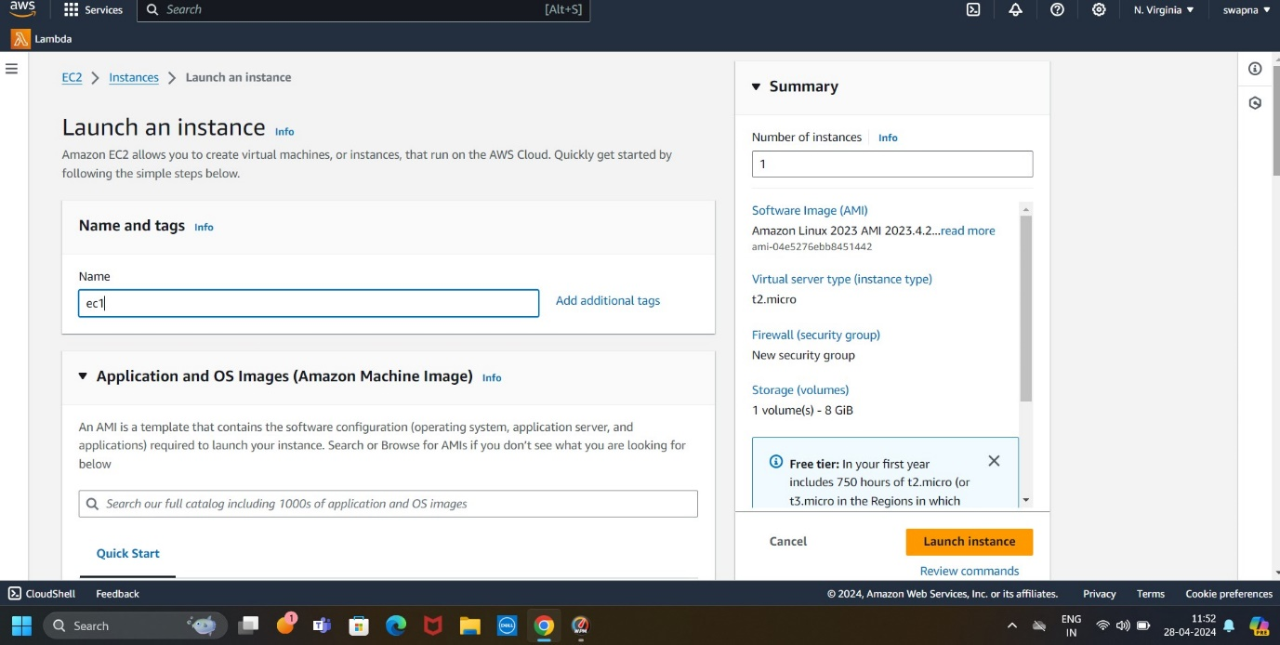

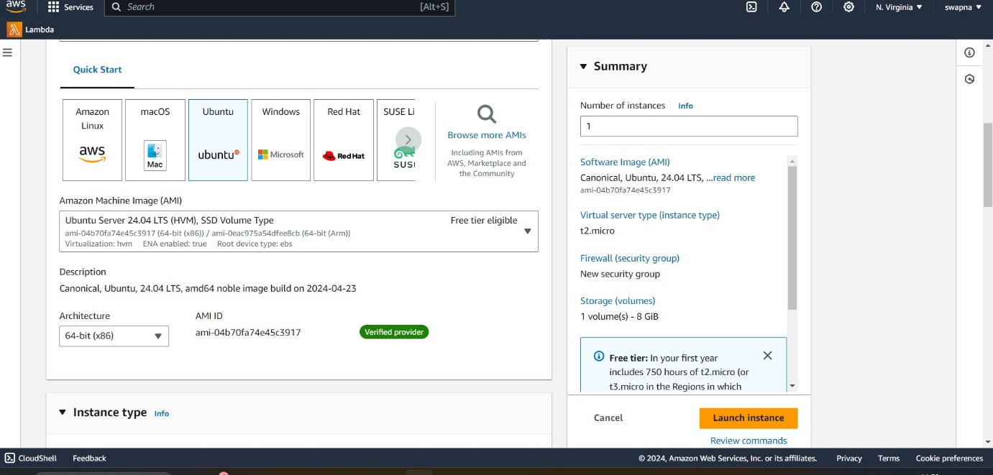

*To create keypair 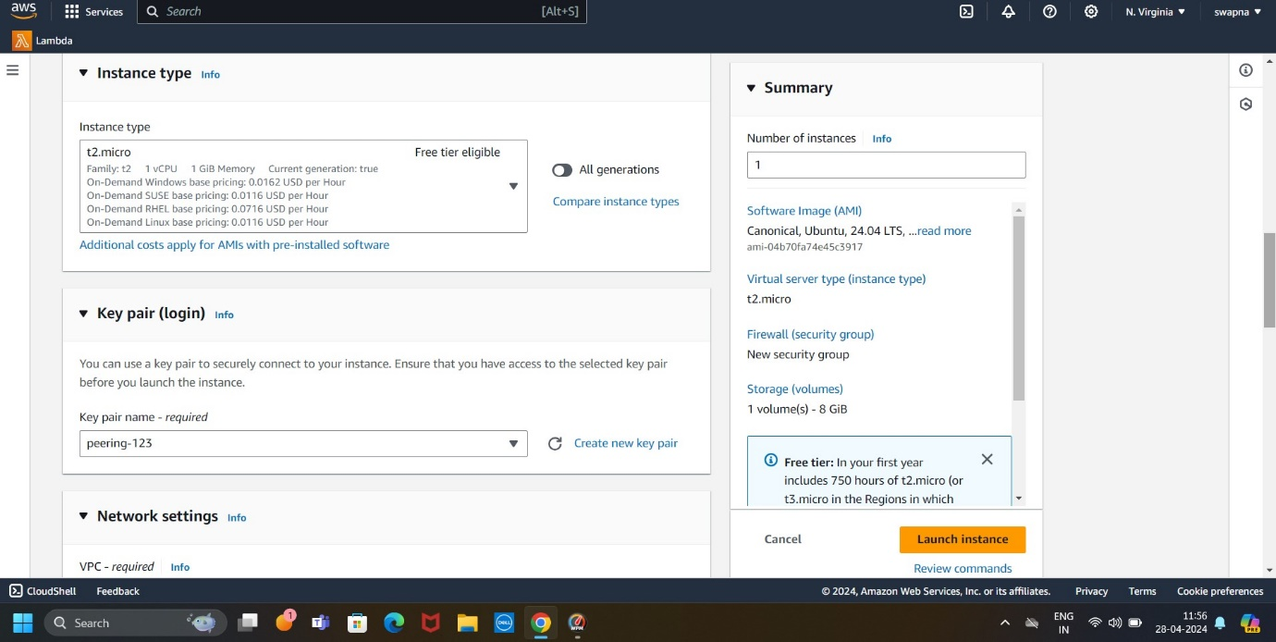

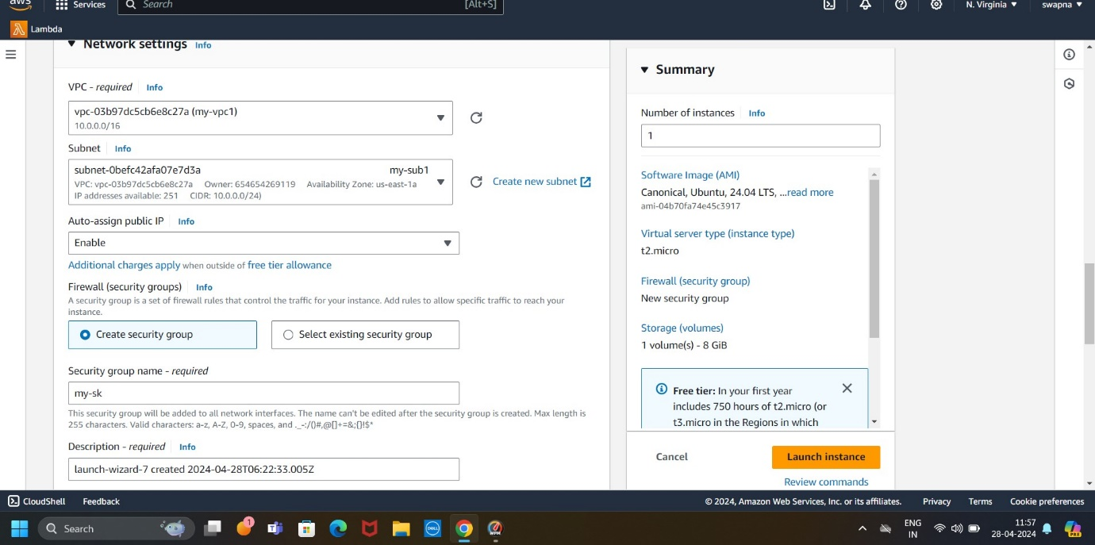

*To creat vpc2 in mumbai

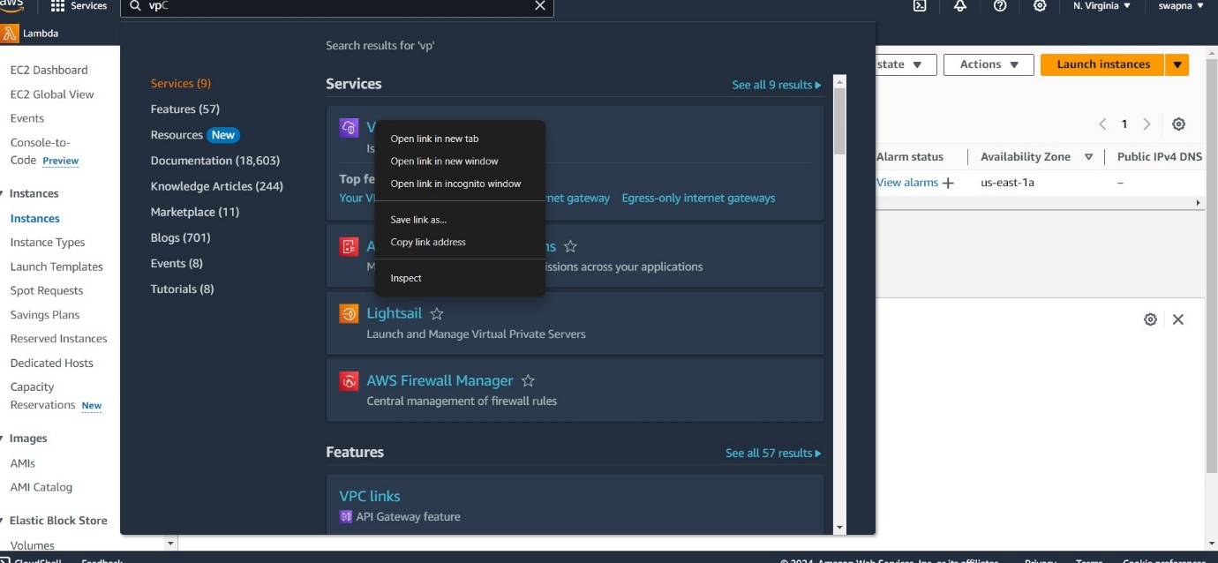

*To create vpc2

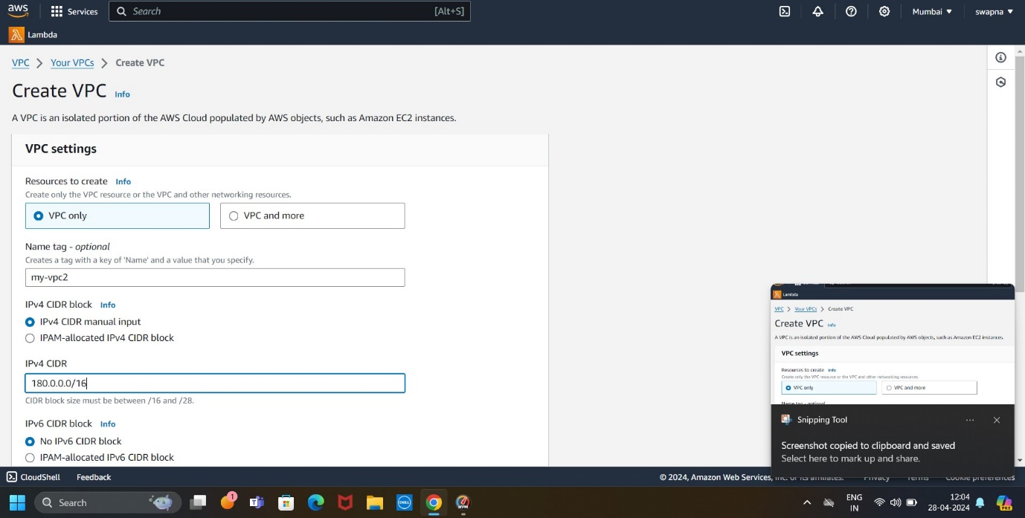

*To create subnet2

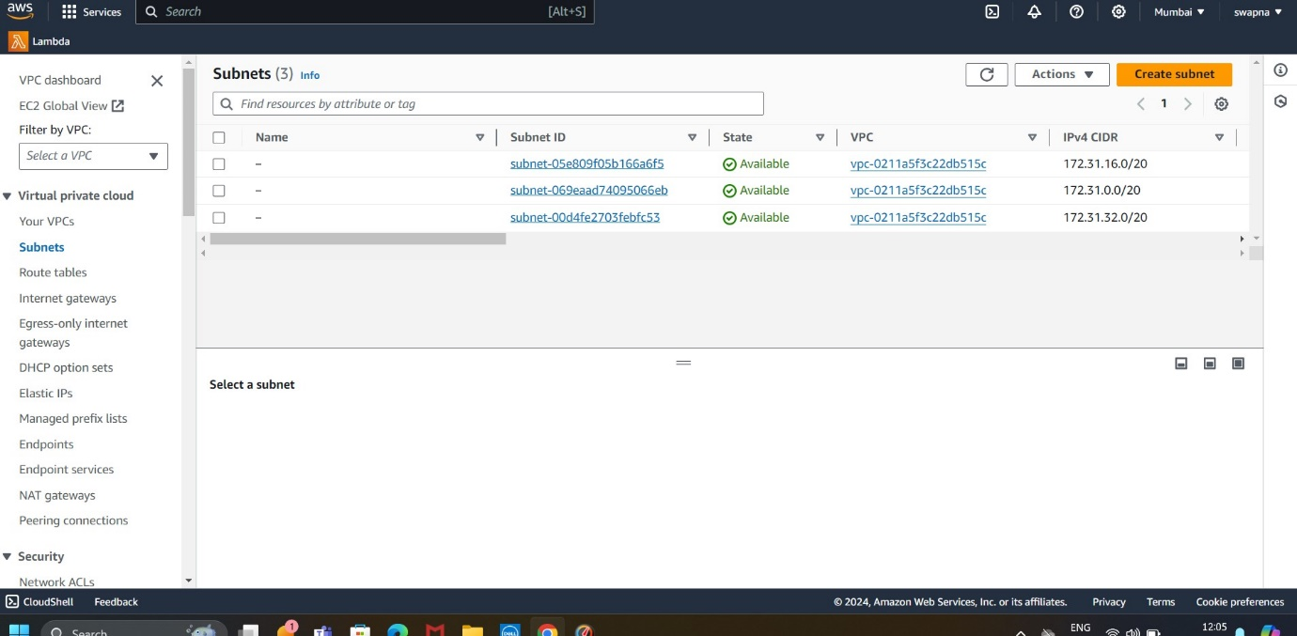

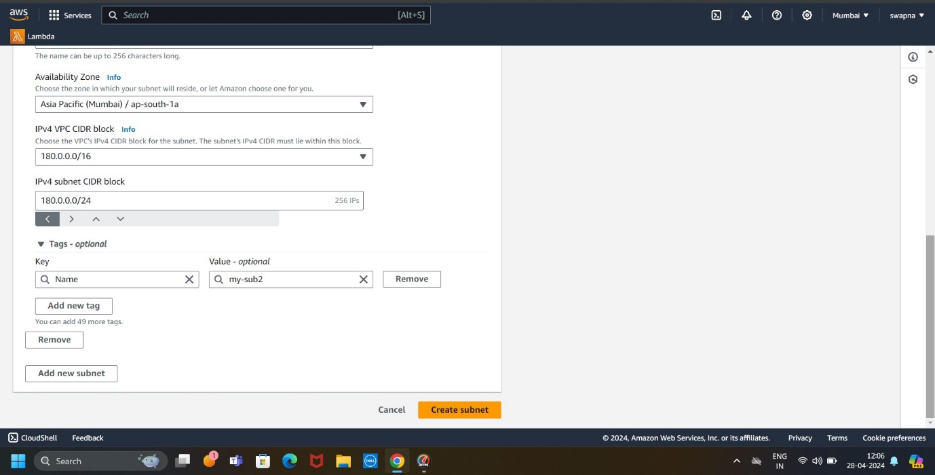

*To create a internat gateway2

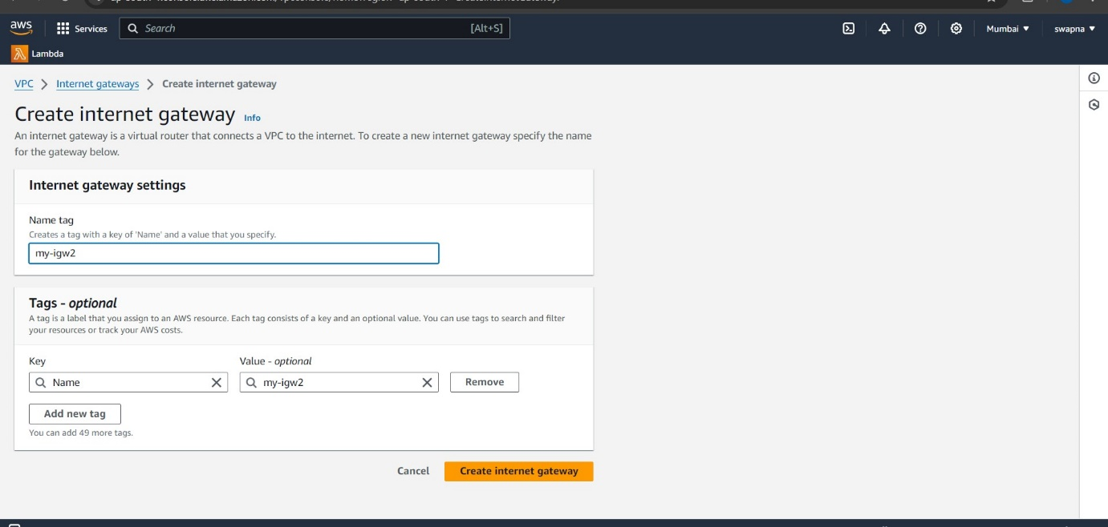

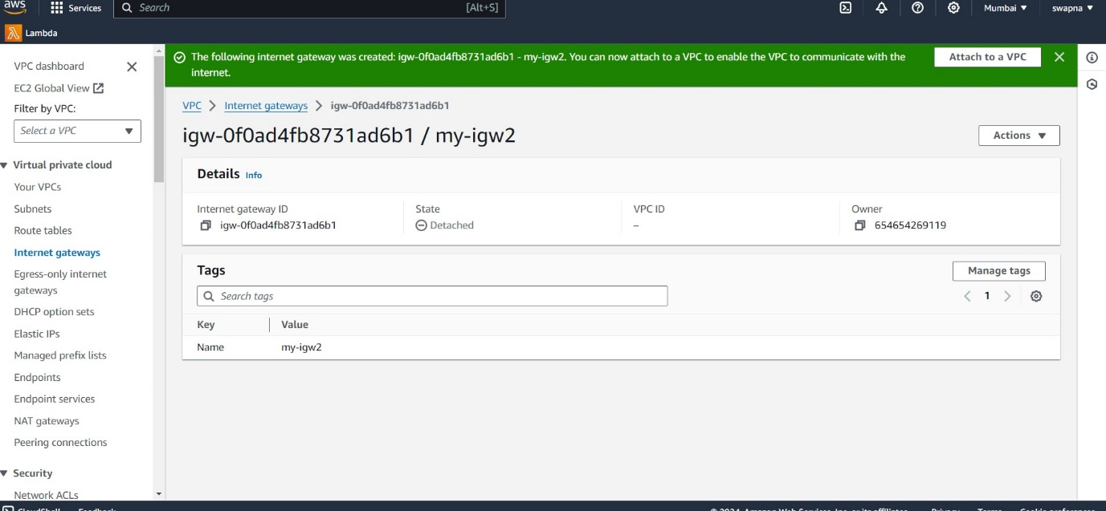

*Attach internet getway to vpc

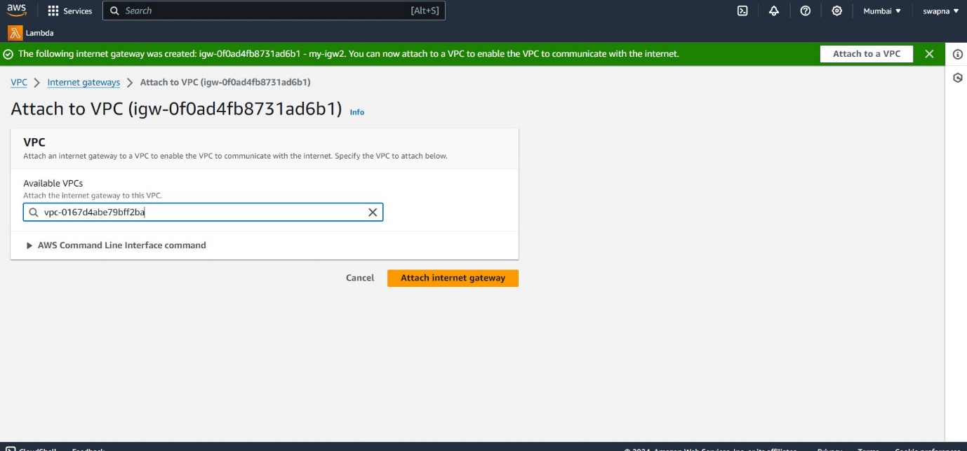

*To create a route table2 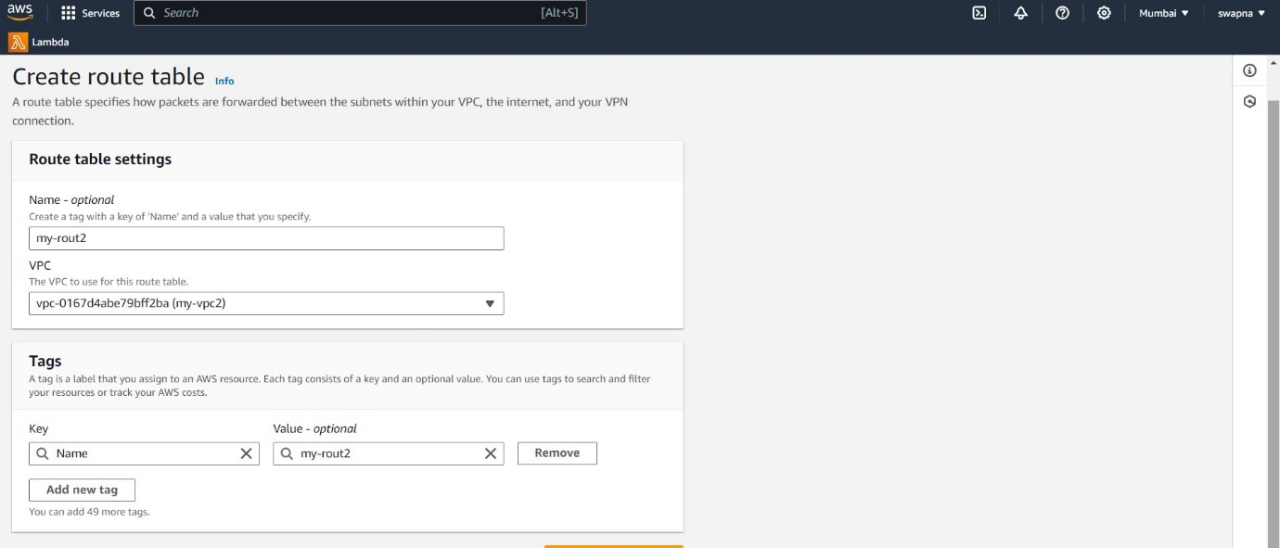

*To create a ec2 instance

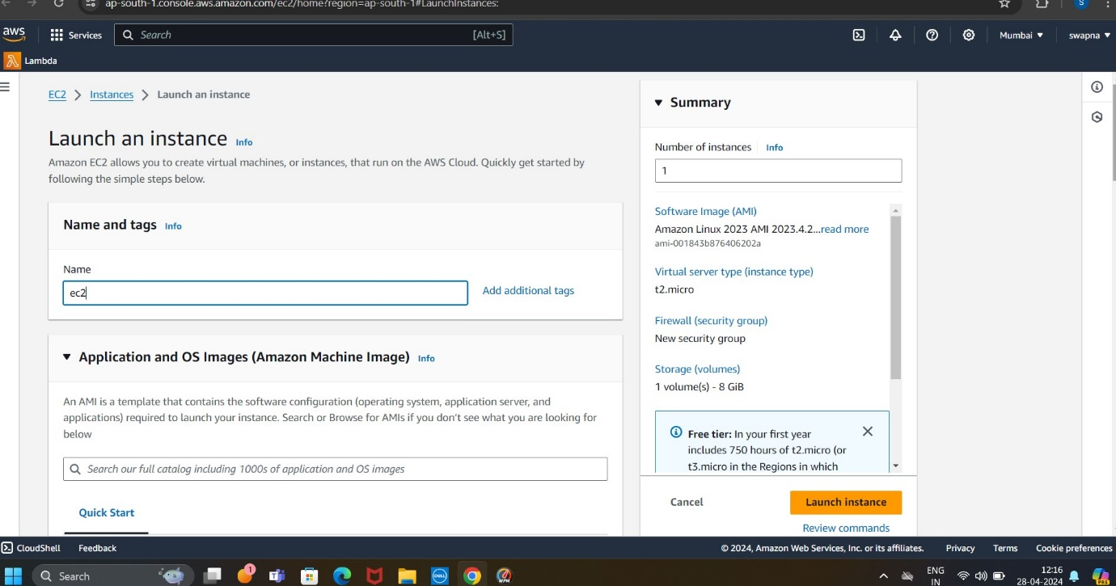

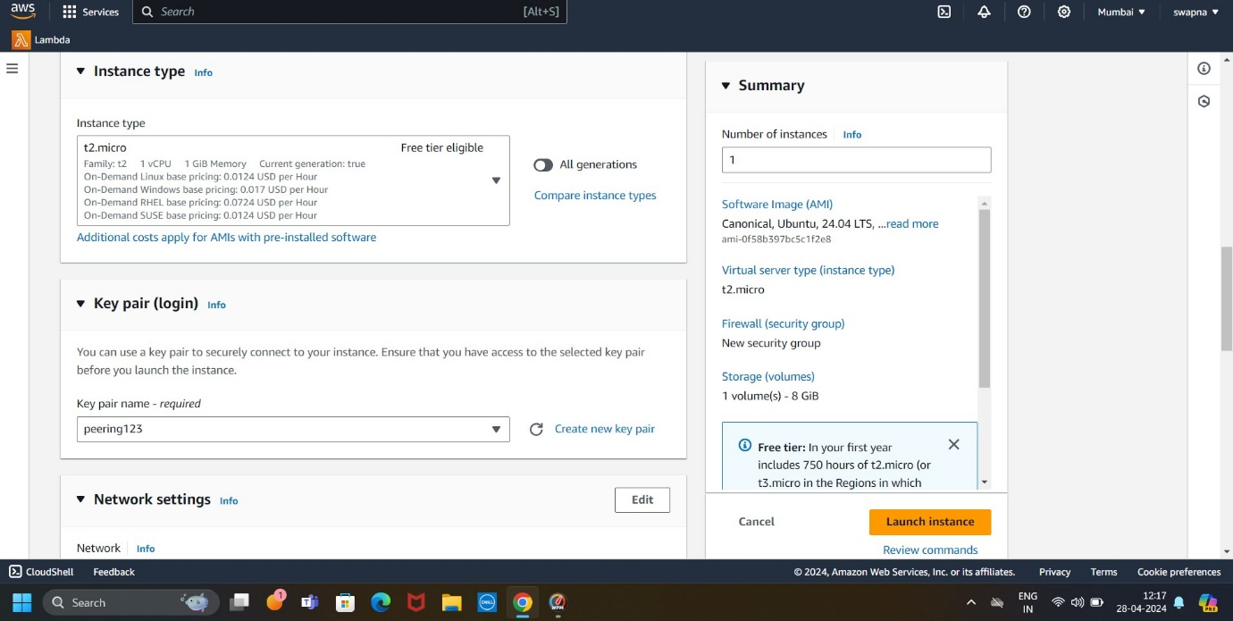

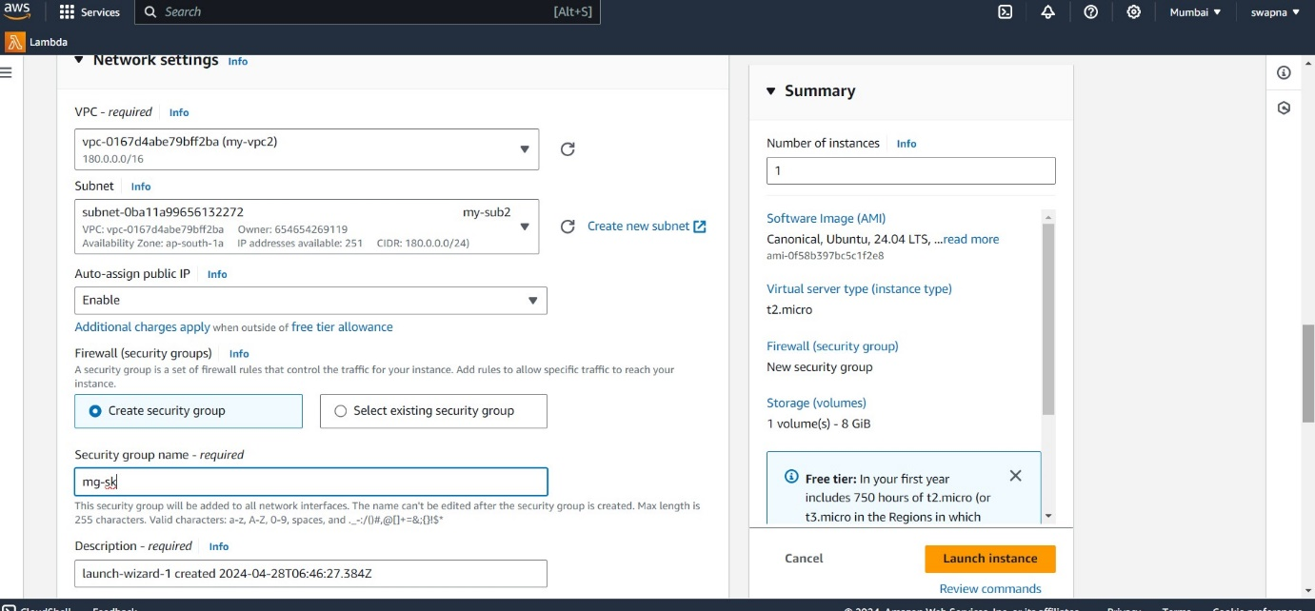

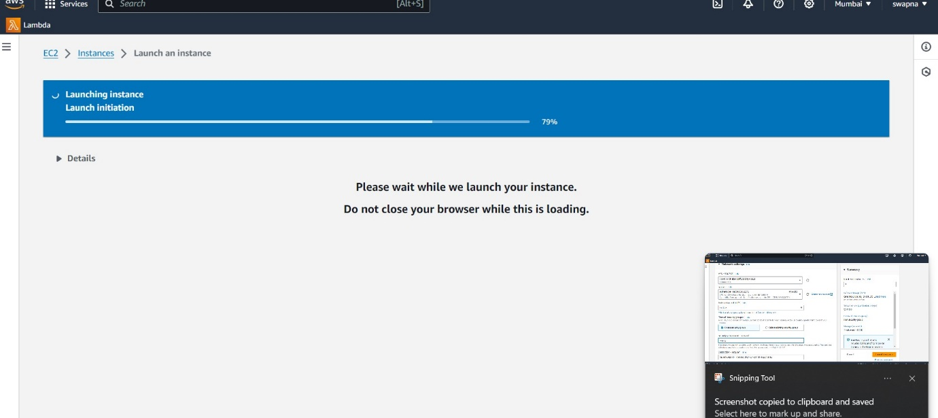

*To create a peering

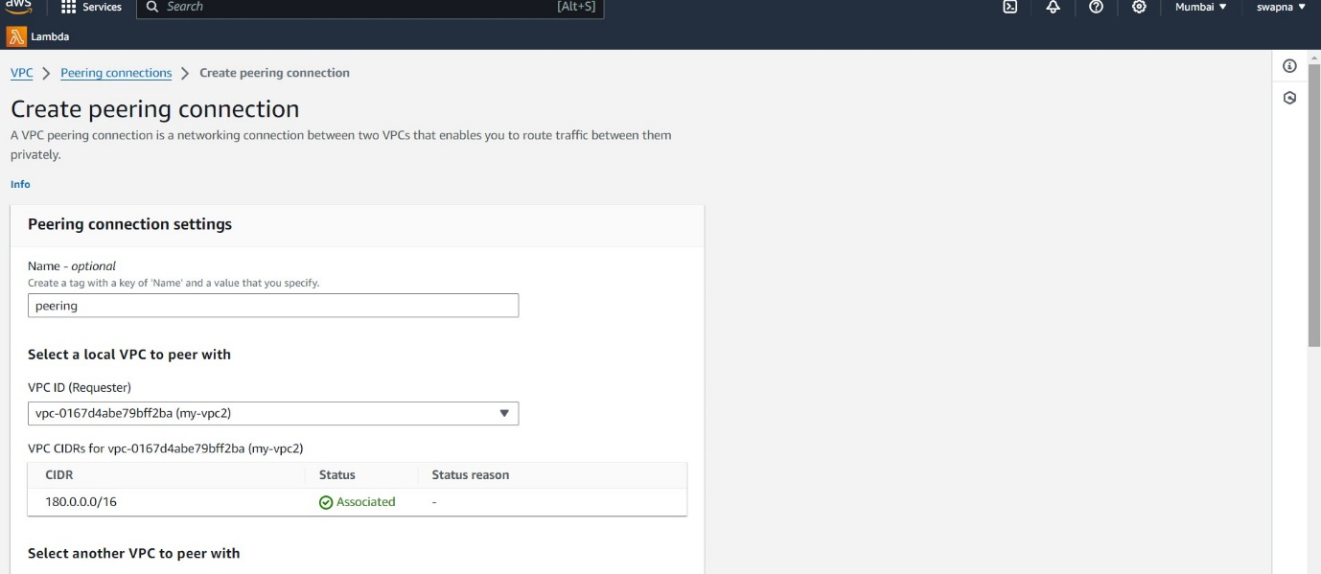

*To secelect another region (vpc1 id)

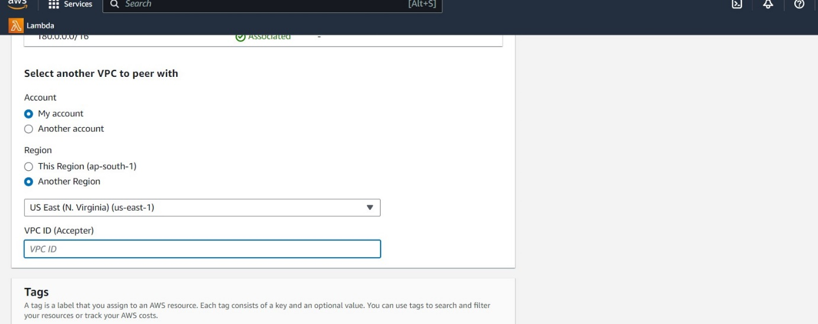

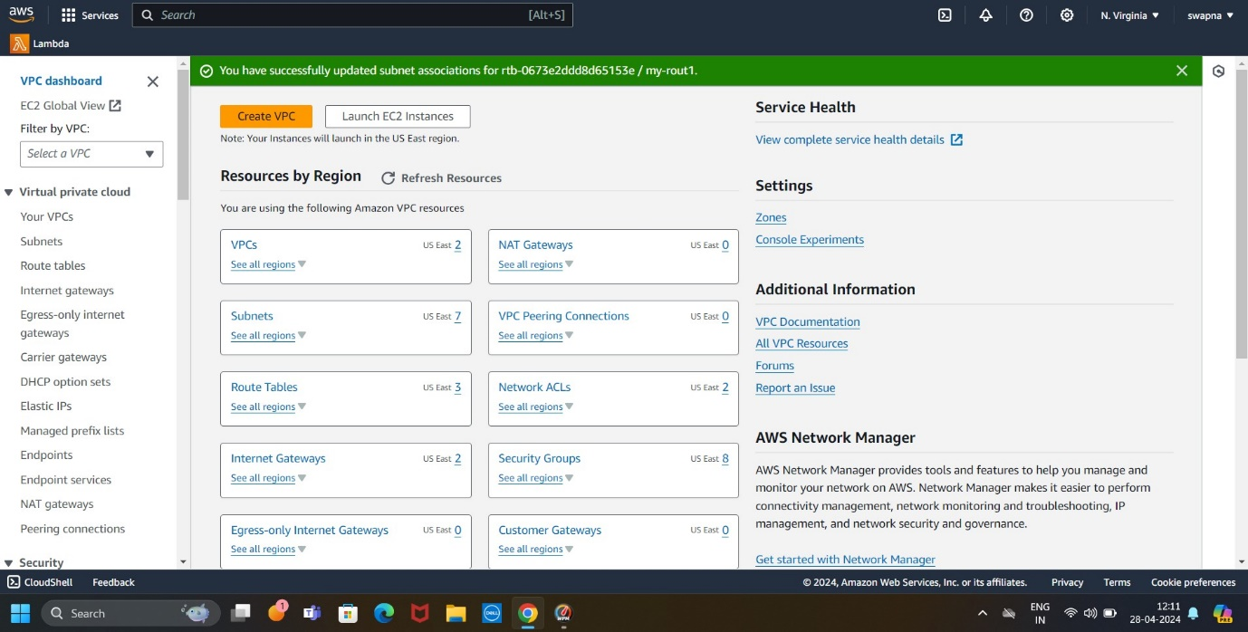

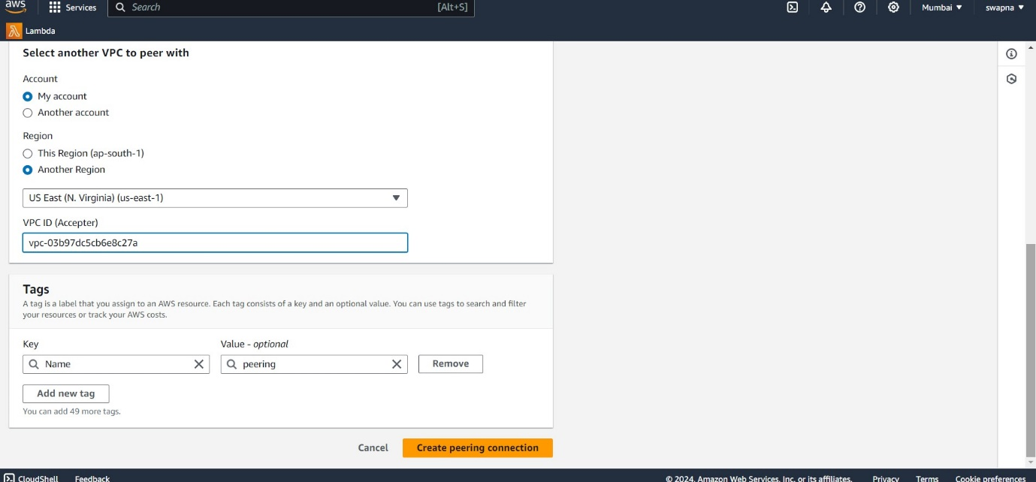

*To request accept peering

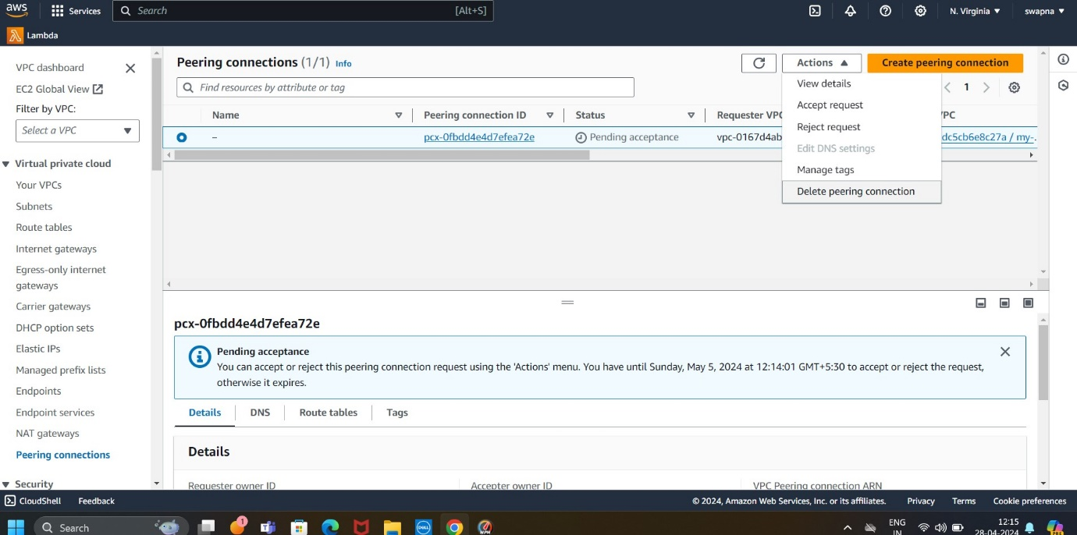

*tha request is accept peering(vpc1 to vpc2)

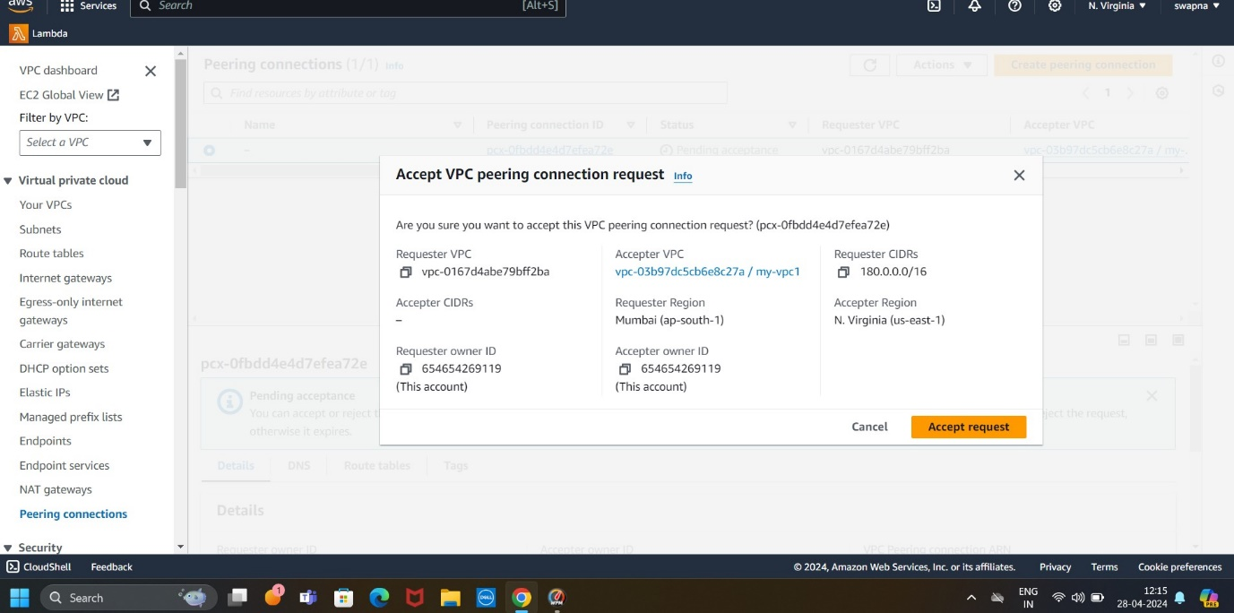

*To connect peering connection to route table2

&give to onether (vpc1 CIDR 10.0.0.0/16)

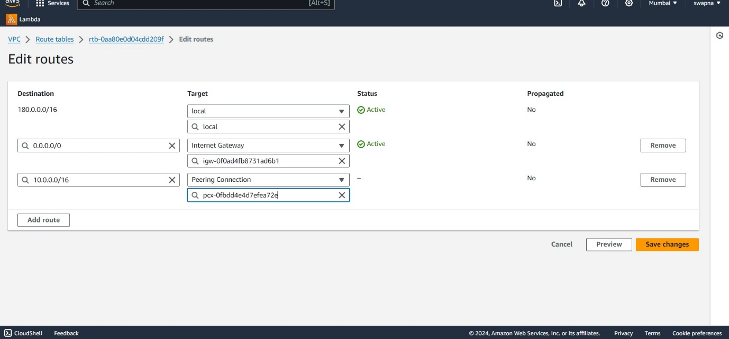

*To connect peering connection to route table1

&give to onether( vpc2 CIDR 180.0.0.0/16)

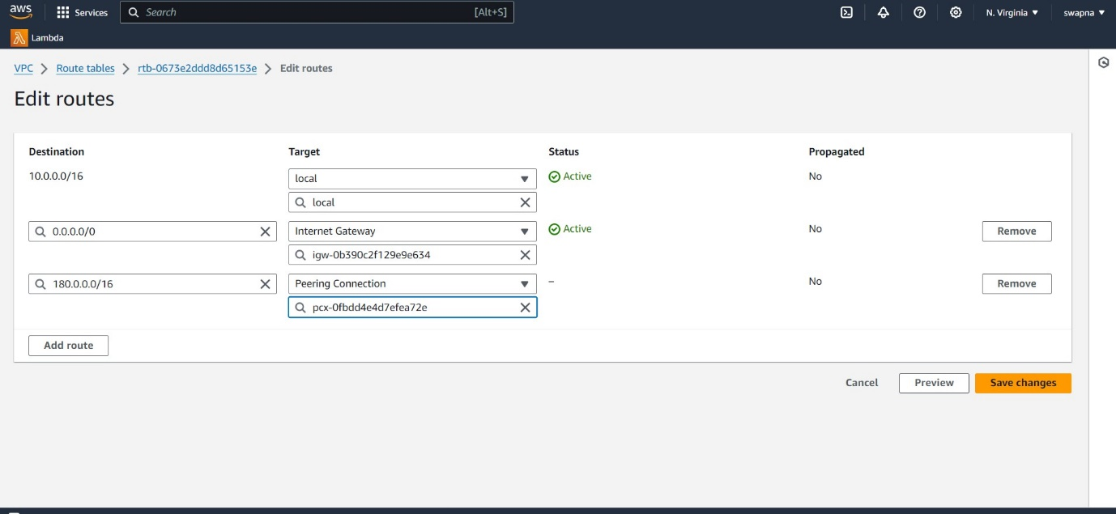

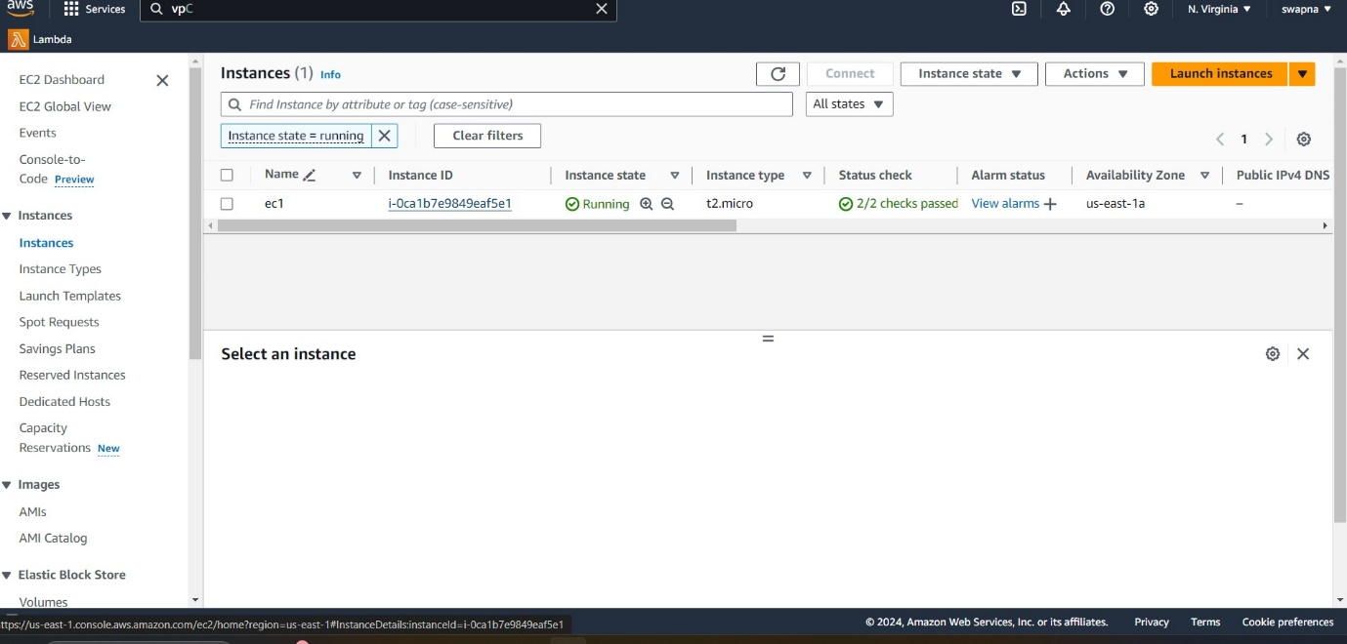

*To connect inbound role to ec1(vpc2 cidr 180.0.0.0/16)

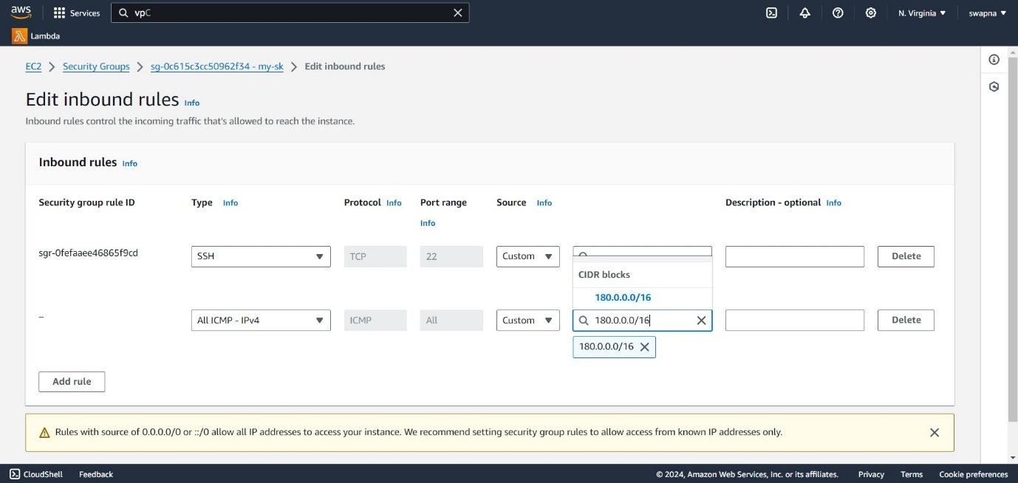

*To connect inbound role to ec2 (vpc1 cidr 10.0.0.0/16)

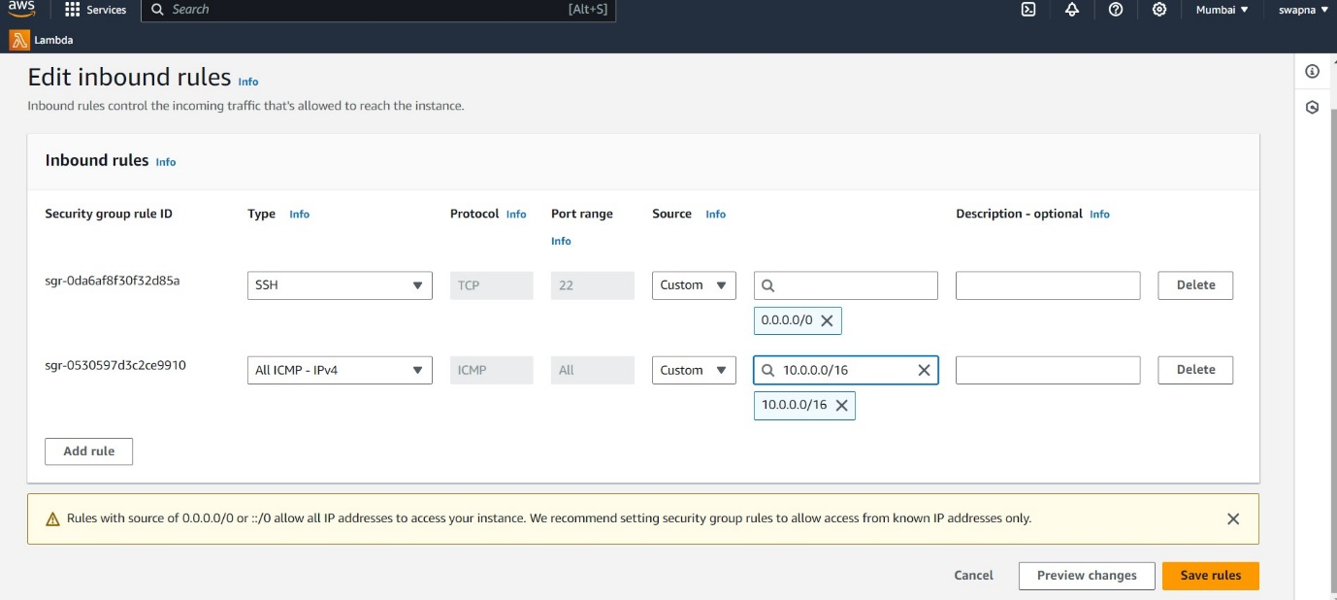

*To connecting ec1 by using peering(virginia)

Command: ping

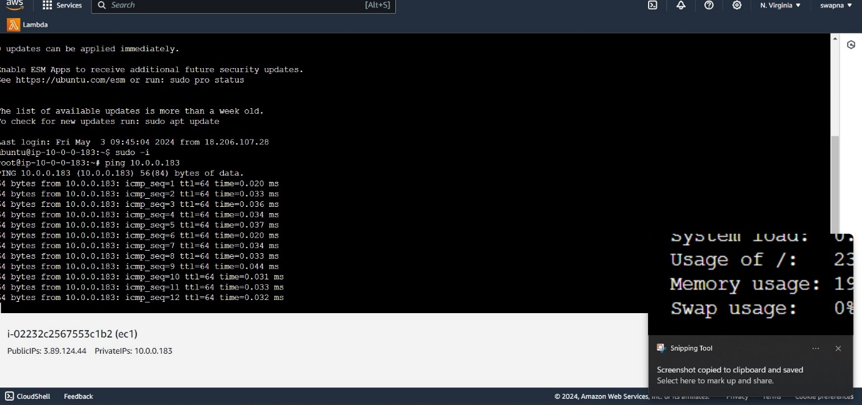

*To connecting ec2 by using peering(mumbai)

Command: ping

